

**BANGLADESH UNIVERSITY OF ENGINEERING AND TECHNOLOGY**

**Report on**

**Java Term Project: Web Browser**

Course Name: CSE 108

Submitted to:

Tanmoy Sen

Lecturer, Department of CSE,

Bangladesh University of Engineering and Tecnology

Prepared by:

S. M. Ahsanul Kabir

Student ID: 1505102

Date of submission: 23.12.2016

**Total Functionality and Functions completed:**

* It can load a web page when a URL is inputed. The given URL will be treated as a String.

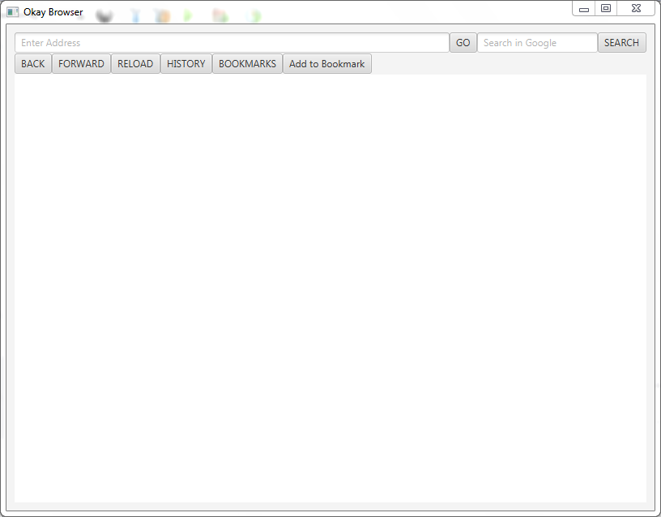

Initial window

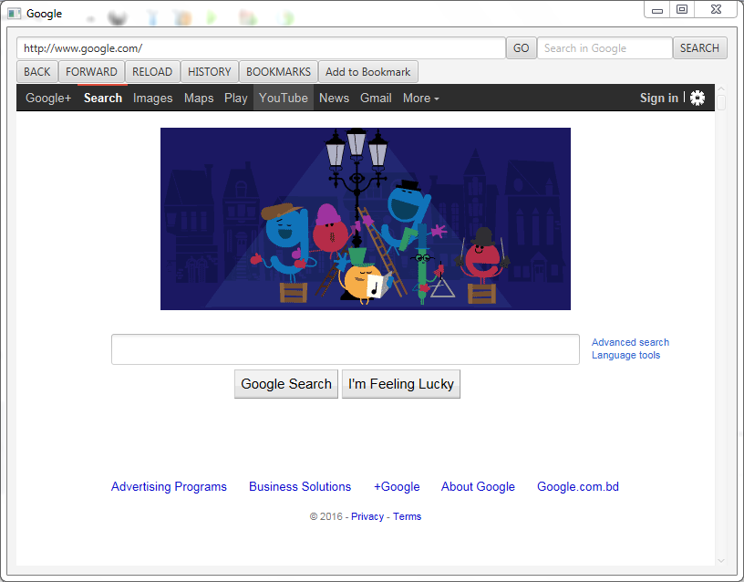

‘GO’ button pressed

* It mostly work on it’s Buttons’ functionality.
* It has a search tab, which can search with the help of google.com.

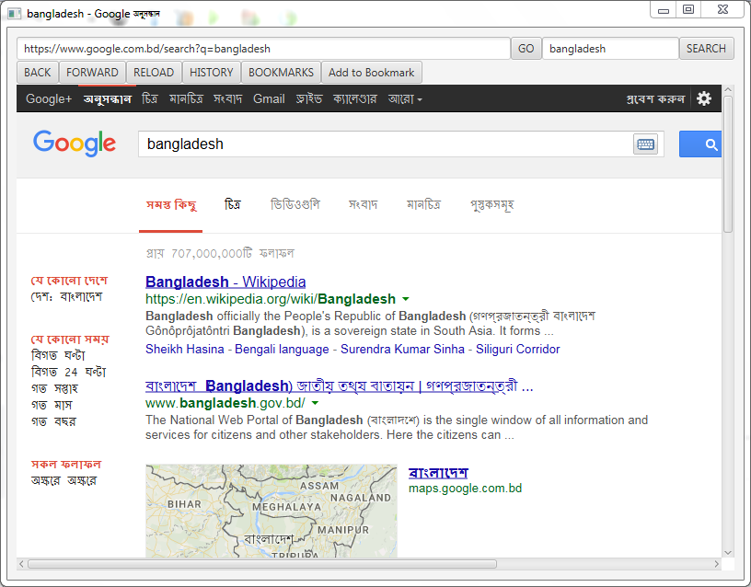

‘SEARCH’ button pressed

* It’s ‘RELOAD’ button can reload the current web page.
* It’s ‘BACK’ button can go back to previous web page calling from WebHistory.

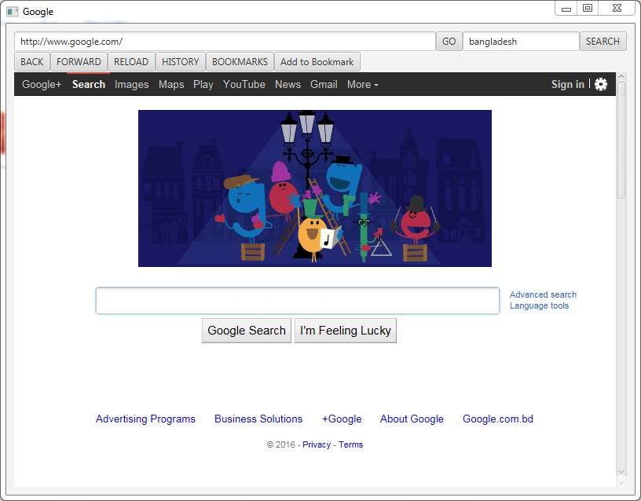

* It’s ‘FORWARD’ button can load a web page which was called before ‘BACK’.

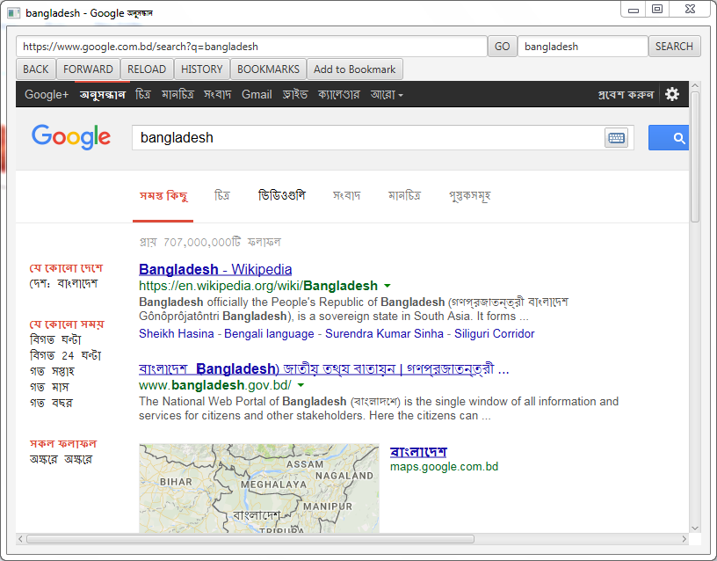

* It has a ‘History’ option which stores URL paths to a text file named ‘History’. History is stored automatically while browsing.

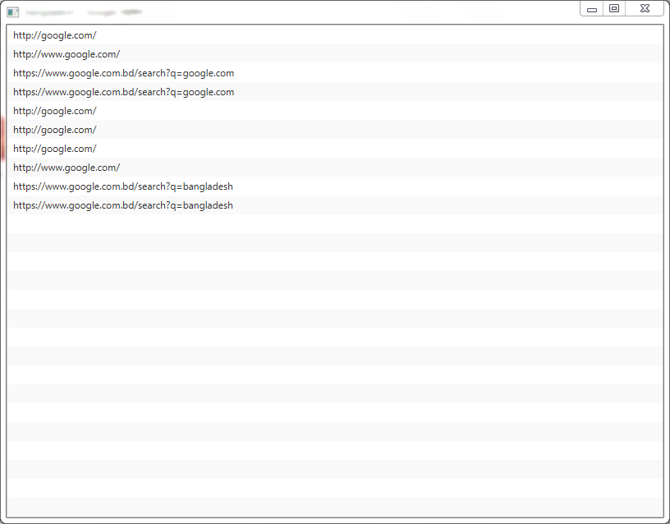

* It has a ‘Bookmark’ option which stores URL paths in ‘Bookmark.txt’ when ‘ADD TO BOOKMARK’ button is pressed.

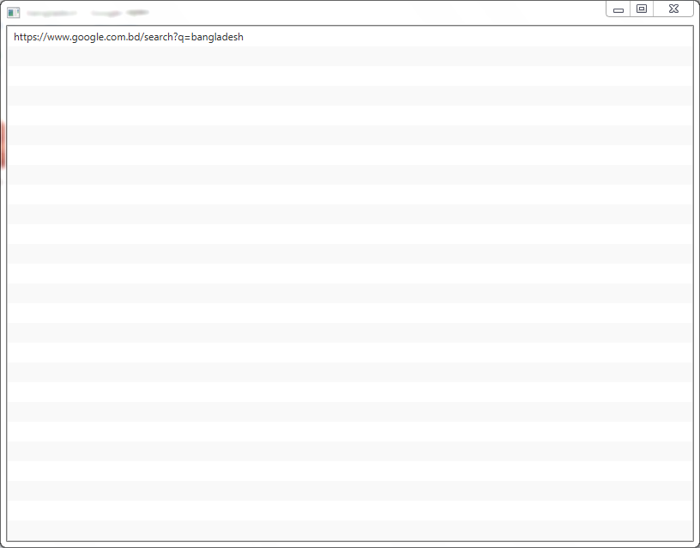

* Web page title, address is updated automatically while browsing.

**Function not completed:**

* I wanted to add tab option, but wasn’t able to complete/debug it.
* In history, URL can’t be pressed to load. This is because they’re stored a String. While loading them from a text file, I wasn’t able to convert Strings to URL (I wasn’t able to find a proper function for this task).
* Bookmark can’t be loaded for the same reason.
* I couldn’t resize the Browser window to an appropriate shape. I tried different functions, but couldn’t debug them in the end.
* Sir told me download a web page. I found that it can be saved as ‘Document’ type. I tried to send the whole page to a ‘Document’. I couldn’t complete the task. This one is may be due to my lack of knowledge about ‘Document’.

**Tools and features used:**

WebView, WebEngine, WebHistory, File, WebHistory, EventHandler (lamda expression).